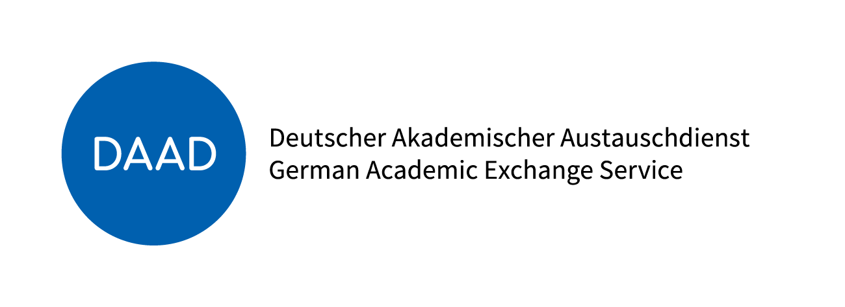

Scholarship Award
Certificate

At the recommendation of the selection committee for the “International Study and Training Partnerships (ISAP)”, managed by the German Academic Exchange Service (DAAD) with financing from the Federal Ministry of Education and Research (BMBF), the NAME OF UNIVERSITY hereby awards

FIRST AND LAST NAME

born DATE OF BIRTH

in PLACE OF BIRTH

a full scholarship (mobility funding, subsistence funding and flat-rate insurance allowance) for the period from DATE to DATE (to be added optionally: in the amount of … Euro) at the PARTNER UNIVERSITY , in DESTINATION COUNTRY).

We congratulate you on this scholarship and wish you a successful stay in Germany. We hope that, in addition to your academic pursuits, you will have the opportunity to become better acquainted with your host country, its people and culture better.

Following your stay in Germany, we would be delighted if you continued your efforts to strengthen international academic collaboration and stayed in contact with the NAME OF UNIVERSITY and the DAAD.

Place, Date Signature

