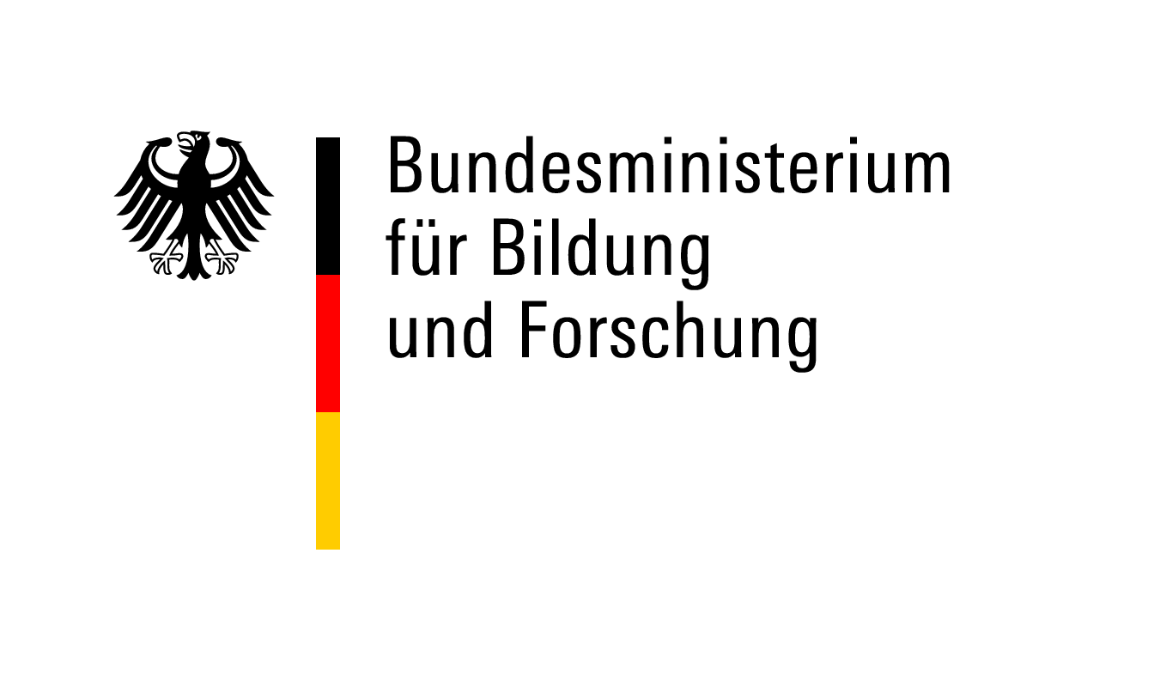

Invitation Letter – German Host
Postdoctoral Researchers International Mobility Experience (PRIME)

Dear German Host Scientists,
One of the prospective applicants in our postdoctoral funding programme PRIME asked you to act as her/his host researcher and supervisor during the PRIME research phase in Germany. Your invitation letter is an essential part of the application.
Please read the following information before drafting your invitation letter:
PRIME is a highly competitive funding scheme for postdoctoral researchers. The average funding ratio in the previous selection cycles has rarely exceeded 15 %.
Applicants must have an excellent academic track record and the research project must be innovative and of high quality. The host institutions in Germany and abroad must provide the perfect research environment to implement the proposed project. A PRIME fellowship should enable the candidates to start an independent research career and to acquire additional scientific/methodological skills. The fellowship is intended to position the candidates as serious competitors for more advanced positions in research.
If you are strongly convinced that the candidate fulfills these requirements and if you fully endorse the research project, please support the applicant with an invitation letter. The letter must detail the support you and your institution provide and outline the career perspectives of your candidate in Germany.
If you find the candidate’s profile not convincing, we strongly recommend that you discuss the matter with the candidate. The candidate may want to look for alternative funding opportunities.
The information provided here is in no way intended to discourage you from supporting an excellent application with your invitation letter. Our intention is to disclose the competitive nature of this funding programme.

Applicant | Bitte angeben
Host/Supervisor | Bitte angeben
University address | Bitte angeben

Invitation Letter
Please insert your invitation letter here. Since the evaluation and selection process is conducted by international reviewers, we kindly ask you to provide your letter in English.

