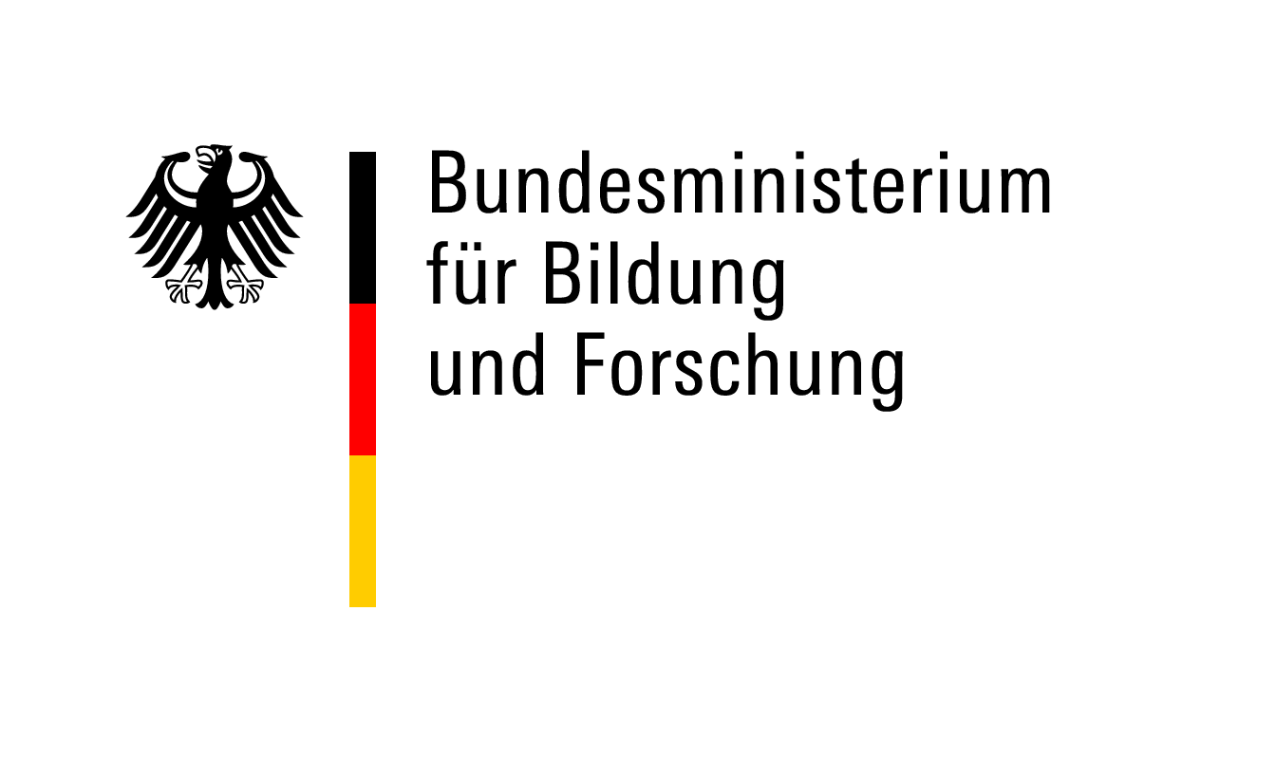

Checklist – Application Documents
Postdoctoral Researchers International Mobility Experience (PRIME)

Documents to be uploaded to the DAAD Portal (make sure to reduce file sizes and to start the upload well before the deadline since it may take some time):

Application form
CV
Career plan
Short summary of the research project (including working title and keywords)
Detailed research proposal
Time schedule
Binding declaration German host university (form 1)
Invitation letter German host (form 2)
Invitation letter foreign host
Degree certificates
Master (or equivalent) with transcripts of records (marksheets)
PhD with transcripts of records (if available)
If PhD not yet completed, statement from PhD supervisor on expected time of completion
Publication list
Short summary of the doctoral thesis
Ethics issues checklist (form 3)
Language certificates (if applicable)
Reference letter
Do not upload documents we don’t need (e.g., certificates for reviews, conferences, sports awards). You can list these activities on your CV.

I have taken note of the call for applications and the programme FAQs. I am aware that only complete applications will be processed. Applications that are incomplete or non-compliant with the programme regulations will not enter the review process.

Place/Date Signature of Applicant

