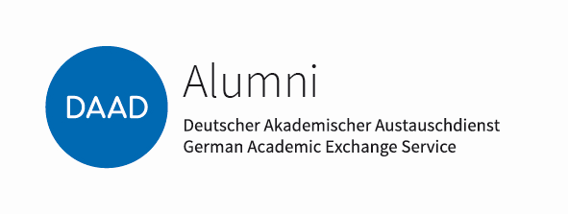 |  | Deutscher Akademischer Austauschdienst  German Academic Exchange Service
Section ST16 –  Alumni: Concept and Coordination |  | E-Mail: daad-alumni@daad.de  Internet: https://www.daad.de/en/alumni/funding-for-alumni-associations/

Application for a Grant towards the Costs of Publications,
and of IT-Equipment
to DAAD Alumni Clubs

Last update: October 2021

Applicant:
Name of the Alumni Club:
Address:
Tel.
E-Mail:
Internet:

Herewith I apply for (please attach brief statement of reasons):
a grant towards online publication: | €
a grant towards computer/IT equipment costs totalling:  (only for countries with limited currency reserves and  developing countries, max. € 2.500,-, please attach com-  parative offers from 3 different companies) | €

The statement from a German diplomatic mission (Embassy, Consulate General, etc.), from a DAAD Regional Office, from a DAAD-Lector, or from the Head of a Goethe Institute

is attached
will be handed in

Applicant's Signature Place, Date

