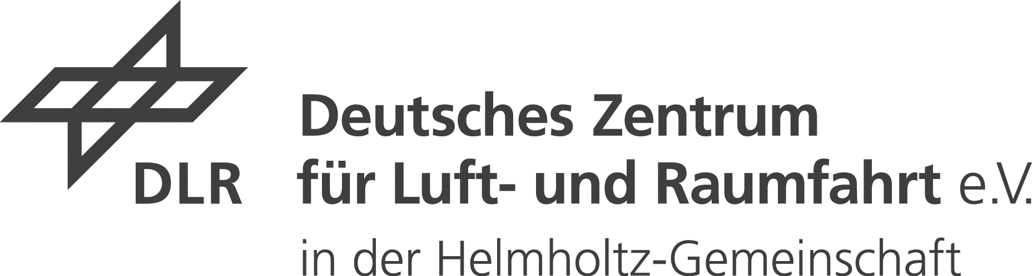  Linder Höhe  D-51147 Köln  Telephone: +49 (0)2203 601-0  Internet: https://www.dlr.de | 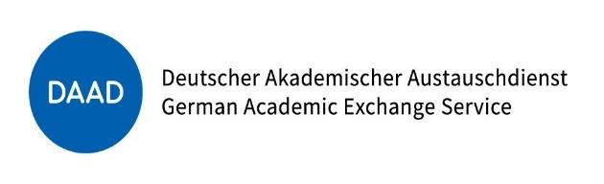  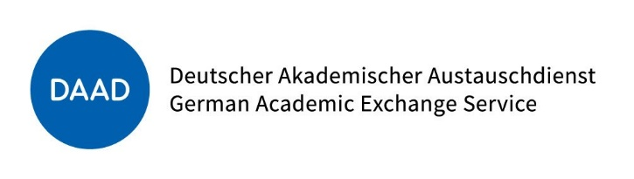  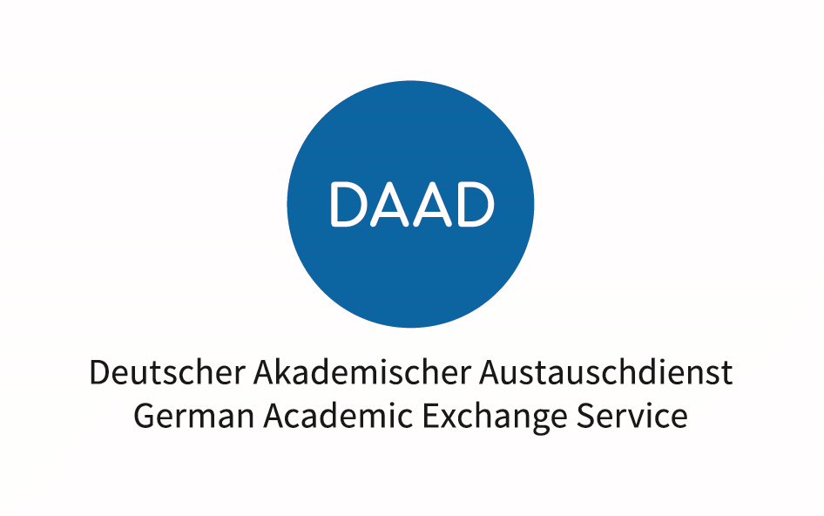  Kennedyallee 50  D-53175 Bonn  Telephone: +49 (0)228 882-0  E-mail: dlr-daad-program@daad.de  Internet: https://www.daad.de/dlr

Application
for a
DLR-DAAD Research Fellowship

Before completing the application form and attaching additional documents please read carefully the special guidelines and conditions of the “DLR – DAAD Research Fellowship Programme” and the respective offer under
www.daad.de/dlr

Name

Nationality

Application for Fellowship No.

DLR Institute

